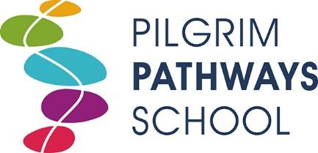

Level 3 Teaching Assistant (Phoenix)
30 hours per week, term time only

We are looking to appoint a dedicated and enthusiastic Teaching Assistant who will work with our existing team with The Phoenix. The Phoenix is a Tier 4 acute psychiatric adolescent unit for students aged 12-18 who stay residentially. Pupils are taught within small teaching groups or on a one to one basis.
- Do you have skills to help deliver KS3 and GCSE curriculum subjects?
- Do you have energy, ambition and resilience?
- Can you deliver warmth and a sense of fun?
- Are you flexible, creative and enterprising?
- Are you a team player and able to work positively as part of a wider team?

The successful candidate will be joining our team of passionate, skilled and friendly practitioners who are committed to providing high quality learning opportunities to young people during their time at the Pilgrim Pathways School.
You will need to have an unconditional and positive regard for the well-being of the young people, have a friendly and patient approach and promote the inclusion of all pupils ensuring they have equal access to opportunities to learn and develop.
The Pilgrim Pathways School is an outstanding alternative provision educating children and young people across four centres based in Fulbourn and Addenbrooke’s Hospital.
You will need to have an unconditional and positive regard for the well-being of the young people, have a friendly and patient approach and promote the inclusion of all pupils ensuring they have equal access to opportunities to learn and develop.

We would encourage you to contact us to arrange to speak with our Head Teacher, Nadine Gooding-Hébert to discuss the role and our school setting. Please arrange this via email to: head@pilgrim.cambs.sch.uk

Pilgrim Pathways School is committed to safeguarding and promoting the welfare of children and all successful candidates will be expected to have a DBS and other relevant employment checks.

Closing Date: 20/03/2023
Interviews: Week commencing 20/03/2023
Position to start: 17/04/2023

