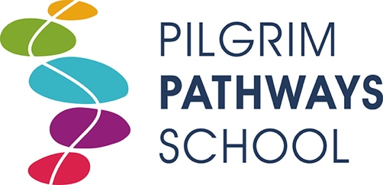
Pupil Premium Spending Report 2020-21

Pupil Premium Carry-forward = £18908.14
Funding Received April 2020 = £16000.00
Funding received April 2021 = £16000.00

Expenditure 2020/21

Herpetology Course £159.66
Raspberry Pi computer £79.00
Arabic Tuition £174.00
Teaching Assistant Salary contribution £5585.00
Total expenditure: £5997.66
Pupil Premium remaining: £10002.34

