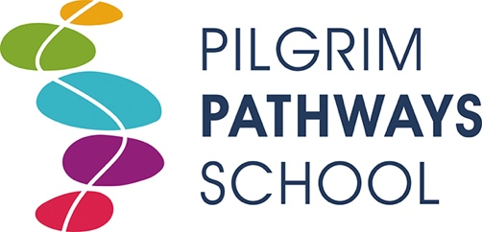
Pupil Premium Spending Report 2022/23

Funding received April 2022 = £16525.00

Expenditure 2022-23

Books (Reading for pleasure) £253.15
PE mentor visits £4922.00
Phonics £1799.67
Phonics (Subscription) £494.95
Engagement activity supplies £122.33
MyMaths (Subscription 2021/22) £199.00
MyMaths (Subscription 2022/23) £210.00
Science equipment (Addenbrookes) £659.69
Science resource pack (Subscription) £99.95
Hamilton Education (Subscription) £135.00
Food Tech (Darwin) £54.33

Total expenditure: £8950.07
Pupil Premium remaining: £7574.93

